Manual Tuning of Parameters

14.15 – Our very first regression model
Without training data that links patients' age to their actual medical expenses, it will be pretty challenging to build a model with any predictive performance. Theoretically speaking, the best we could do is guess. But if we at least knew the average medical expense across individuals, we could make that guess a little bit more informed. Instead of picking a random number and hoping for the best, the best model in this situation always predicts the same value. Specifically, no matter what we might know about the individual (age, sex, etc.), we always predict that the patient's medical expenses will be equal to this mean, see Equation 14.7.

(14.7)
Equation 14.7 - Our first regression model simply outputs the mean of all previously observed outcomes as its prediction.

Technically, this is a predictive model, albeit not very good. But it is a good starting point to start understanding the r-squared metric. Figure 14.12 plots the data and the function that describes our machine learning model. And indeed, no matter what the input to our model could be (age), our prediction remains the same, as any point on the x-axis maps to the same value on the y-axis.

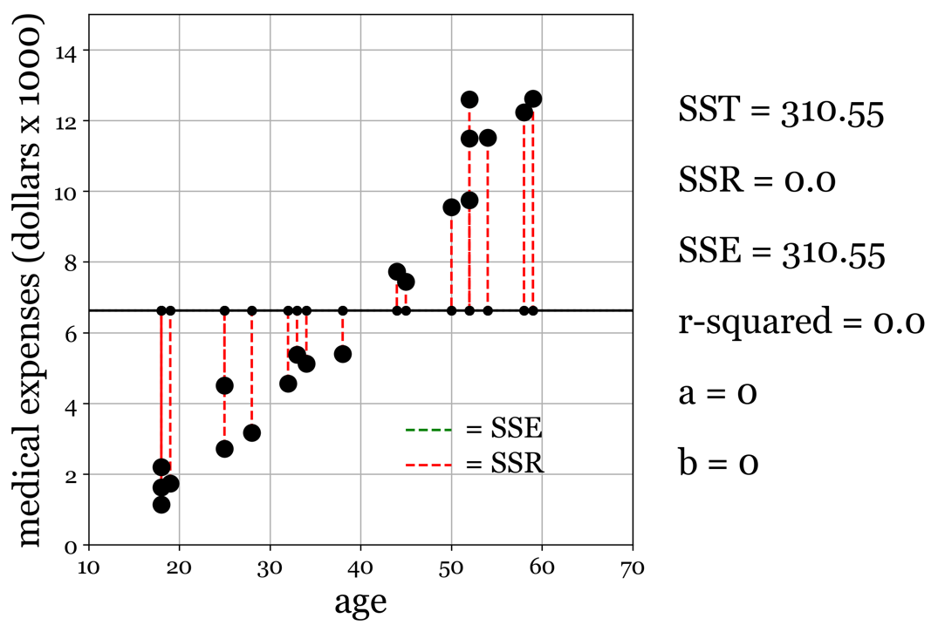
Figure 14.12 - Our first regression model simply outputs the mean of all previously observed outcomes as its prediction, utterly agnostic to the patient's age.

This agnostic approach of our model is not doing us any favors. There is substantial predictive power in the data, as increases in age are paralleled by increased medical expenses. A closer look at the equations we defined for computing the total variance, explained variance, and residual variance shows our model to be a perfect edge case in computing the r squared. The sum of squares totals the difference between each output y_{i} and its mean. By setting our model output to be the same, mean the equation for the SSR (the amount of variance in the output data we explain using our model) will always be zero, see Equation 14.8. So, the amount of variance explained by our model, relative to the total amount of variance in the output, is 0. As a result, our r-squared is at exactly 0, the worst r-square to be awarded to a machine learning model.

(14.8)
Equation 14.8 - A model that always predicts the mean of previously encountered outputs y will never explain any variation in y, making it quite useless.

14.17 – Improving performance - introducing a positive slope
We can do better than our first attempt. By eyeballing it, it seems there is a positive relationship between expenses and age. Therefore, our slope a should be positive. Second, just by being born, you probably already have some medical expenses. So, the intercept b should also be positive, as it reflects the base predicted expenditure at age = 0. Using a = 0.05 and b = 4 (given that we standardized the medical expenses to US dollars x1000, we suggest that on day one as a newborn, you will have 4000 dollars of medical expenses to your name on average. When we run the numbers, we see that our model isn't very good, but better than predicting the mean for sure, with an r-squared of 0.11.

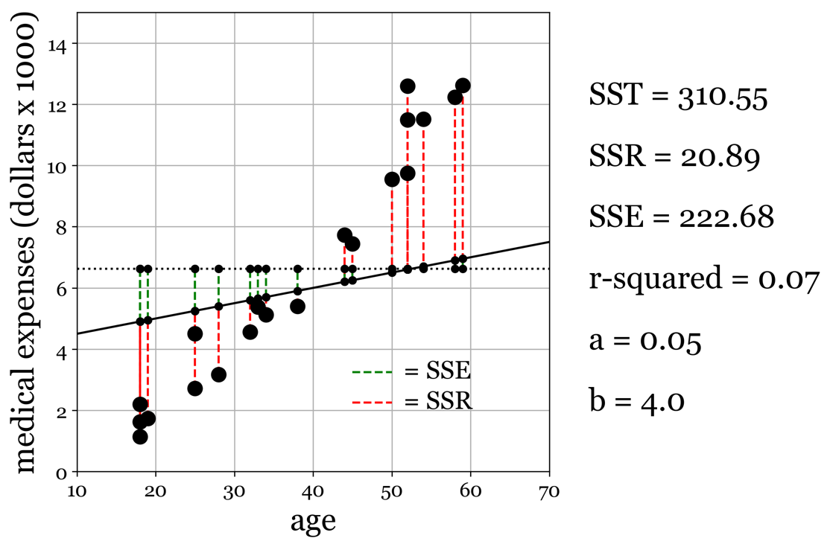
Figure 14.13 - Our second model has a positive slope (a=0.05) and positive intercept (4.00). You can interpret these parameters as follows: the amount of medical expenses predicted is 50x your age (since a=0.05, one year is 0.05 times $1000 = 50 dollars), plus a baseline 'out of pocket' of $4000 (b=4.0). By the age of 30, our model predicts you will have $50 * 30yr + $4000 = 5500 dollars of medical expenses. Reasonable assumptions aside, our model isn't all that great performance-wise. A positive slope is a good starting point, but we must change it further for a closer fit.

14.18 - Improving performance - an empirical constraint
Perhaps we were a little too negative, assuming infants have a non-zero amount of medical expenses the day they are born. So, as a subsequent attempt, we set b = 0, which means that no matter what, we will predict you will have 0 dollars in medical expenses on day 1. Whatever happens after that is solely a function of the slope of our function, which is given by our parameter a. This fit significantly improved over the previous two models, yielding an r-square of 0.5. However, some data points for older people are off quite a bit compared to their younger counterparts.

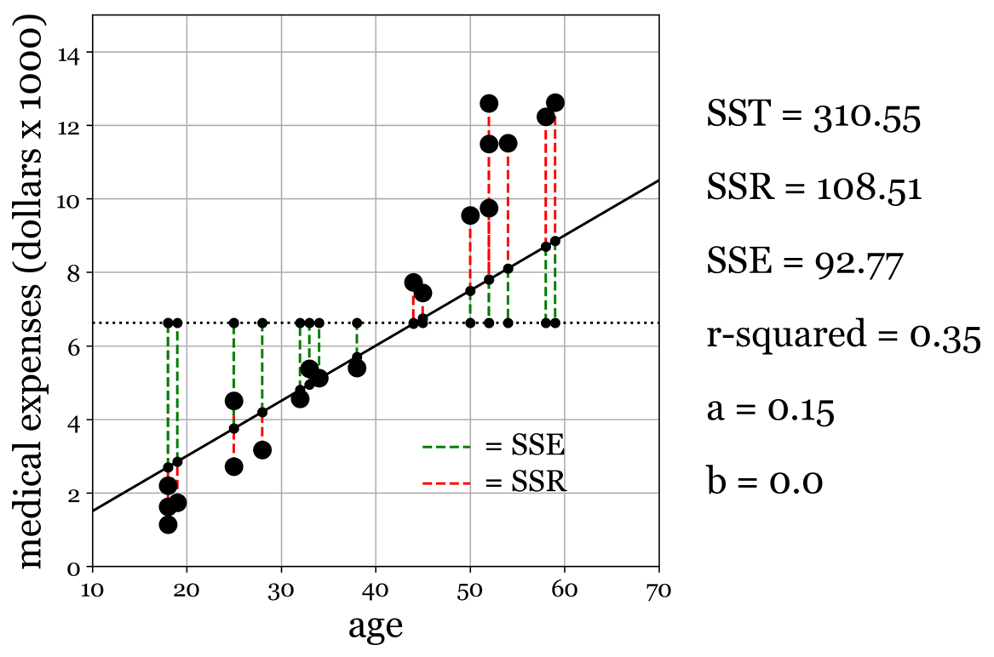
Figure 14.14 - Our third model uses an intercept b = 0, forcing the slope to explain the variance in our outcome data y. We get reasonably close with our fit this time round, but we can still improve the model further.

14.19 – Improving performance - close to ideal.
We decided to be a little adventurous for our final manually tuned model. We increase the slope a to 0.25 while at the same time setting our intercept b to be negative (b=-2.25. An interesting choice since a negative intercept means that when you are born, the insurance company owes you money, as your medical expenses are predicted to be negative. Surely, insurance companies don't give out one-time bonuses to newborns, even if there is the expectation they will make that money back by quite a margin later during that individual's life. To be fair, this 'day one bonus' is an interpretation of the model. A negative intercept can also mean that the linear model just falls short of being able to explain the observed data. And this isn't surprising. If we look more closely at the data in 14.9A, we can see that the relationship isn't entirely linear. There is a non-linear effect that accelerates a person's medical expenses in the same way compound interest accelerates the growth in your savings. Most likely, this is an exponential effect with an exponent greater than 1 (an exponential component of 1 resolves to a linear model). This explains why a negative intercept works well. The data flattens out towards the younger individuals, intersecting close to (0,0) or assuming that at age = 0, you will have $0 worth of medical expenses. The linear model is unable to 'flatten out'. It continues unabated below $0 worth of expenses. Despite this inability of our linear model to accurately describe or predict medical expenses at an early age, overall, its performance is quite exceptional for a manually tuned set of parameters, yielding an r-squared of 0.90.

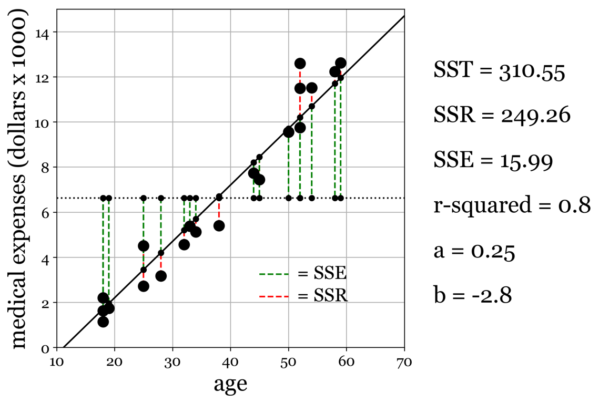
Figure 14.15 - Our fourth and final hand-tuned model does well. With a negative intercept (b < 0) and a positive slope (a < 0), we capture a large portion of the variance in observed outcomes.

14.20 - R-squared vs. Correlations
The r-squared and correlation coefficients are often confused and used interchangeably. This is incorrect. A correlation coefficient is bound between -1 and 1 (completely negative to completely positive), whereas the R-square is bound between 0 to 1 (no variance explained to all variance explained by our model). Furthermore, we can get a high R-square even when our correlation is low. Think back to output signal y that doesn't change as a function of x. This means there should not be any significant correlation between x and y. However, our model can still be a good fit if that model would simply output the mean value of y for any x, and y shows a low amount of variation.

14.21 - It's only model
As we observed, the relationship between age and medical expenses isn't linear. There is a slight quadratic or exponential component in how medical expenses increase with age. However, the performance we got out of it was robust and yielded good predictions across different inputs. It is not uncommon for edge cases to represent themselves in your data. At the extremes of your data, non-linear effects might creep up. In addition, there are usually fewer data at these extremes to drive the overall push toward finding the best parameters.


Figure 14.16 - In the end, our models simplify the complex interplay of causes and effects.

Ultimately, our models are just simplifying some more complex interplay of causes and effects. This makes models valuable tools in science. Yes, they do not always tell the complete story of everything going on at the empirical level. But in many scenarios, extra details might improve the accuracy by which they can describe and predict our observations, but at the cost of explanatory value. For example, we know now that Newton's equations that describe motion break down when we consider objects the size of planets, stars, and galaxies. At these scales, we must use the equations put forward by Einstein's theory of relativity instead. But it is sufficiently accurate in describing the trajectory of a game-winning home run. However, humans have now created technologies that operate at a scale where Einstein's equations are preferred. For example, our global position system, consisting of many earth-orbiting satellites working in unison, must factor in the effects of gravity to correctly triangulate positions on the earth's surface.

